STOCK PRICE PREDICTION

PHASE III REPORT

Submitted by
Supervisor:-Ms. Harsh Sharma (E13523)
Co Supervisor:- Mr. Siroj Kumar Singh(E13617)

NAME OF THE CANDIDATE(S)
NAME - UID
ANMOL SHAKYA - 20BCS5146
BUNTY PRASAD NAYAK - 20BCS1160
DEVANSH TIWARI - 20BCS1235

in partial fulfillment for the award of the degree of

BACHELOR OF ENGINEERING
IN
COMPUTER SCIENCE AND ENGINEERING


Chandigarh University
OCTOBER & 2022

CHAPTER 3.
DESIGN FLOW/PROCESS

Evaluation & Selection of Specifications/Features
- A stock market prediction is described as an action of attempting to classify the future value of the company stock or other financial investment traded on the stock exchange. The forthcoming price of a stock of the successful estimation is called the Yield significant profit. This helps you to invest wisely for making good profits.

- The future price of a stock is the main motivation behind the stock price prediction. In various cases like business and industry, environmental science, finance and economics motivation can be useful. The future value of the company’s stock can be determining.

Analysis and Feature finalization subject to constraints
Stock Market
Analysis of stocks using data mining will be useful for new investors to invest in stock market based on the various factors considered by the model.
Stock market includes daily activities like sensex calculation, exchange of shares. The exchange provides an efficient and transparent market for trading in equity, debt instruments and derivatives.
Our model will be analyzing sensex based on company’s stock value. The stock values of company depend on many factors, some of them are:
1> Demand and Supply:
Demand and Supply of shares of a company is a major reason price change in stocks. When Demand Increase and Supply is less, price rises. and vice versa.
2> Corporate results: This will be regarding to the profits or progress of the company over a span of time say 3 months.
3> Popularity: Main Strength in hands of share buyer. Popularity of a company can effect on buyers. Like if any good news of a company, may result in rise of stock price. And a bad news may break dreams.
The stock value depends on other factors as well, but we are taking into consideration only these main factors.

Prominent features of the Project:

A. Analyzing stock data.
We need to provide data of a particular company, and its Monthly Sales / Profit report with Months High and Low points of its Stock.
B. Analyzing the factors.
We have to obtain the data in the same period for the following factors.
1. Demand and Supply: We will obtain by the previous data entered.
2. Corporate results: Companies declare their performance results and profit at the end of each quarter.
3. Popularity: If any news about a company is about to come and is it bad or good.
We have to analyze the variations in the stock value of the companies with respect to these factors using some data mining algorithms.

Design Flow
Model -
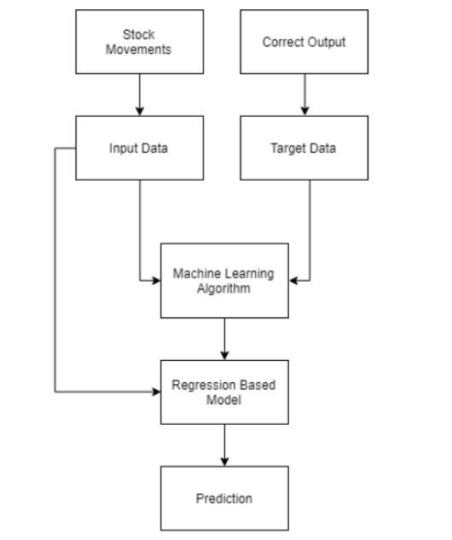
Fig 1. Model of the project

USER BASED-
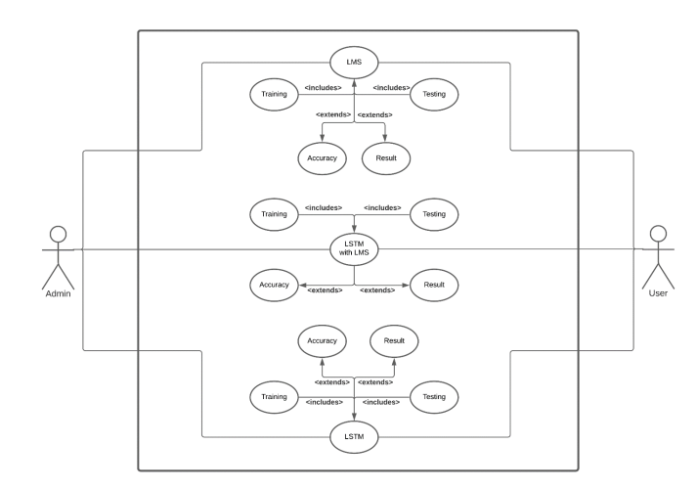
Fig 2.Used Based Diagram

Design selection
Stock market prediction seems a complex problem because there are many factors that have yet to be addressed and it doesn’t seem statistical at first. But by proper use of machine learning techniques, one can relate previous data to the current data and train the machine to learn from it and make appropriate assumptions. Machine learning as such has many models but this paper focuses on two most important of them and made the predictions using them.

Implementation plan/methodology

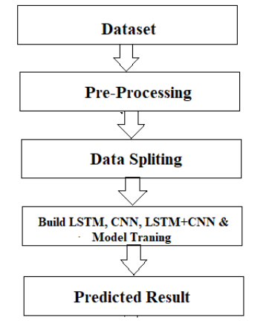
Fig 3.Methodology of the project

The system presented here composes of five modules:-
- Input as Dataset
- Pre processing
- Data splitting
- Build & Model train Lstm
- Output as Predicted Result.

PYTHON
The language of select for this project was Python. This was a straightforward call for many reasons.

1. Python as a language has a vast community behind it. Any problems which may be faced is simply resolved with visit to Stack Overflow. Python is the foremost standard language on the positioning that makes it is very straight answer to any question.

2. Python is an abundance of powerful tools ready for scientific computing Packages. The packages like NumPy, Pandas and SciPy area unit freely available and well documented. These Packages will intensely scale back, and variation the code necessary to write a given program. This makes repetition fast.

3. Python is a language as forgiving and permits for the program that appear as if pseudo code. This can be helpful once pseudo code give in tutorial papers should be required and verified. Using python this step is sometimes fairly trivial.

However, Python is ] not without its errors. The python is dynamically written language and packages are area unit infamous for Duck writing. This may be frustrating once a package technique returns one thing that, for instance, looks like an array instead of being an actual array. Plus the standard Python documentation did not clearly state the return type of a method, this can’t lead without a lot of trials and error testing otherwise happen in a powerfully written language. This is a problem that produces learning to use a replacement Python package or library more difficult than it otherwise may be.

2 NUMPY- Numpy is python package which provide scientific and higher level mathematical abstractions wrapped in python. It is [20] the core library for scientific computing, that contains a provide tools for integrating C, strong n-dimensional array object, C++ etc. It is also useful in random number capability, linear algebra etc. Numpy’s array type augments the Python language with an efficient data structure used for numerical work, e.g., manipulating matrices. Numpy additionally provides basic numerical routines, like tools for locating Eigenvectors.

JUPITER NOTEBOOK - The Jupyter Notebook is an open-source web application that enables to making and sharing documents that contain visualizations, narrative text, live code and equations. Uses include: data , data visualization, data transformation, statistical modelling, machine learning, numerical simulation, data cleaning and much more.

REFERENCES
- A. Ben-Hur and J. Weston. A user's guide to support vector machines. In O. Carugo and F. Eisenhaber (eds.), Data Mining Techniques for the Life Sciences, pp. 223--239. Springer, 2010.
- Bing Search API. Windows Azure Marketplace.
- N. K. Chowdhury and C. K.-S. Leung. Improved travel time prediction algorithms for intelligent transportation systems. In Proc. KES 2011, Part II, pp. 355--365.
- A. Cuzzocrea, C. K.-S. Leung, and R. K. MacKinnon. Mining constrained frequent itemsets from distributed uncertain data. FGCS, 37: 117--126, July 2014.
- T. Finley and T. Joachims. Training structural SVMs when exact inference is intractable. In Proc. ICML 2008, ACM, pp. 304--311. ACM.
- D. Hodges. Is your fund manager beating the index? MoneySense, 15(7):10, Dec. 2013/Jan. 2014.
- T. Joachims, T. Finley, and C.-N. J. Yu. Cutting-plane training of structural SVMs. Machine Learning, 77(1): 27--59, Oct. 2009.
- D. E. King. Dlib-ml: a machine learning toolkit. JMLR, 10: 1755--1758, July 2009.
- V. Kolmogorov and C. Rother. Minimizing nonsubmodular functions with graph cuts-a review. IEEE TPAMI, 29(7): 1274--1279, July 2007.
- C. K.-S. Leung, F. Jiang, and Y. Hayduk. A landmark-model based system for mining frequent patterns from uncertain data streams. In Proc. IDEAS 2011, pp. 249--250. ACM.

